Task 7: Year 11 Electrical Physics Test Solutions

Name: ___________________________ Mark ______________________/31

Question 1 ( 1 mark)

Which of the following is the correct definition for electric current?

A the charge per unit volume per unit time

B the charge per unit volume

C the charge per unit time

D the time per unit charge

C

Question 2

How does the effective resistance of two identical resistors in parallel (*R*T) compare to the resistance of each individual resistor (*R*)? ( 1 mark)

A *R*T = *R*

B *R*T < *R*

C *R*T > *R*

D It depends on the resistance, *R*.

B Rt is less than R

Question 3

Calculate how much current is drawn by a 6.0 W torch globe that uses two 1.5 V batteries placed in series? ( 2 marks)

*Vtot= 1.5+ 1.5 = 3.0V*

*P=VI so I=P/V=6/3 = 2A*

Question 4

Describe the energy transformations that occur during the operation of the circuit shown below when the switch is closed. (3 marks)

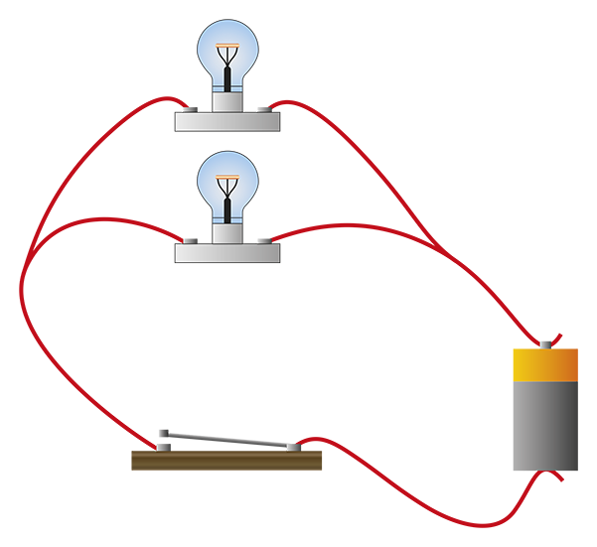

*Chemical potential energy stored in the chemicals in the battery is transformed into electrical potential energy as the chemical reactions separate charges within the battery. (1)*

*When the circuit is connected, the charge separation establishes an electric field within the wires. This electric field exerts a force on the electrons within the wire. This results in a conversion of electrical potential energy to kinetic energy. (1)*

*Kinetic energy of the electrons is transformed into heat and light within the bulb when electrons collide with the atoms within the filament of the bulbs.* (1)

Question 5

**a** Samantha discovers that the 12.0 V battery in her new car is connected via one switch to   
two heater elements (resistors) in parallel, one resistor is used to heat the driver’s seat and   
one resistor is used to heat the passenger’s seats. Draw a labelled diagram to represent this circuit. (3 marks)

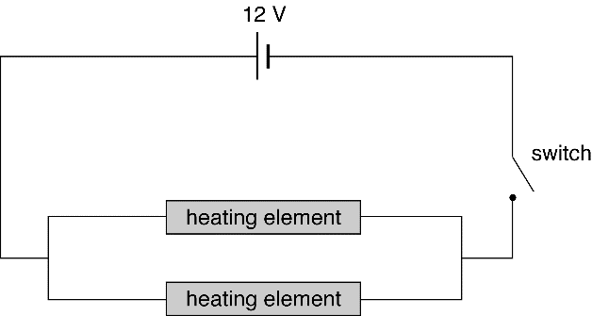

*1 mark each for a parallel circuit and correct symbols and labels.*

b Thinking that the seats are not heating properly Samantha decides to check operation of the switch by measuring the voltage drop across the heaters. Draw how she would attach the voltmeter to the circuit in part a. (2 marks)

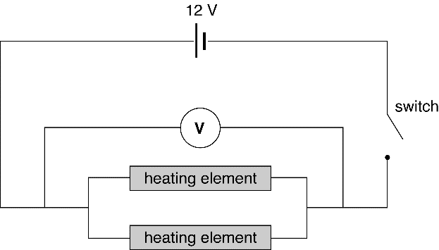

*1 mark each for correct symbols and correct positioning of voltmeter leads.*

**c** When the switch is open, what value should the voltmeter read? (1 mark)

V *= 0 V*

d When the switch is closed, what value should the voltmeter read? (1 mark)

V = 12 V

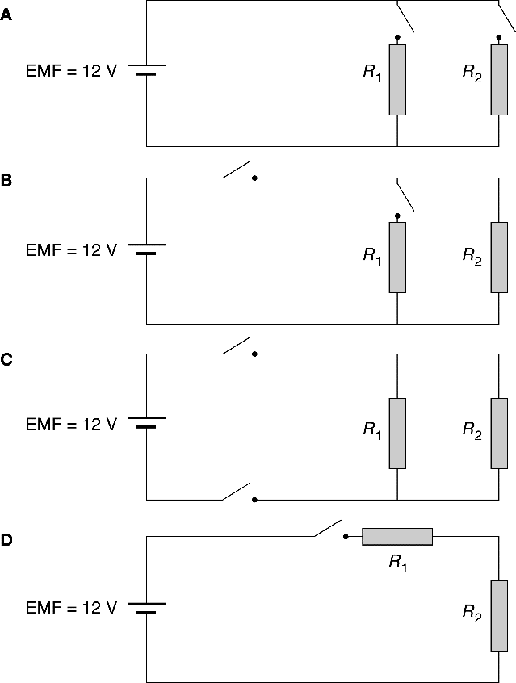**e** Samantha takes her car to an auto electrician who rewires the seat heating circuit to allow each seat to be individually heated. Which circuit diagram shows this? (1 mark)

Circuit A

**f** The resistors are identical and are rated at 300 Ω. What is the total resistance of the   
circuit when both seats are heated at the same time? (2 marks)





*R*T = 150 Ω

**g** What current is drawn when both seats are heated at the same time? (1 mark)

I=V/R=12/150=0.080A =80mA

Question 8

A battery in a circuit has current of 4.50 A passing through it.

**a** How many coulombs of charge pass through the battery in 5.00 s? (1 mark)

*q*= It = 4.50 × 5.00 = 22.5 C

**b** If the battery provides a potential difference of 9.00 V, how many joules of energy does it provide to the circuit each second? (2 marks)

energy = *VIt* = 9 × 4.5 × 1 = 40.5 J

Question 9

**a** How much energy, in kilowatt hours and joules, will a 200 W globe use in 4.00 hours of operation? (2 marks)

E = Pt = 200 × 10–3 x 4.00 = 0.800 kWh or 200 × 4.00 × 3600 = 2.88 × 106 J

**b** An electricity company charges 60.0 cents per kW h of electricity consumed. How much does it cost to use this 200 W globe for 30 minutes? (2 marks)

Cost = 0.200 × 0.5 × 60 J

= 6.0 cents

**Question 10**

650 Ω

200 Ω

600 Ω

1. Calculate the total resistance of the circuit ( 3marks)



Ω

 Ω

1. Calculate the current that flows through the 600 Ω resistor when the output of the power supply is 6.00 V. (3 marks)





